Crosschecked with DB
Org Id: 105007940
Month: 2023-03
In File
I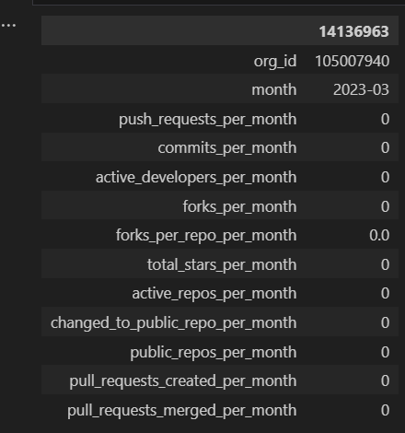

Org id: 61058094
Month: 2022-09
